33.51: a) 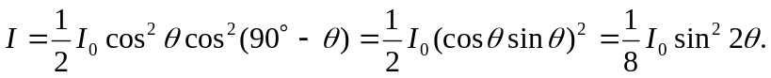
b) For maximum transmission, we need 